**Cross Platform App Development Lab Experiment No. 2**

**Aim:** Setting up the development environment of React Native and .NET MAUI on Windows and building first simple application.

**Objectives:**

1. The objective of this lab is to install the development environment for React Native on a Windows system and build a simple application using frameworks.

**Theory:**

1. **React Native:**

React Native is a JavaScript framework for building mobile applications that can run natively on iOS and Android devices.

It allows developers to use React along with native platform capabilities to create high-performance, cross-platform apps.

1. **Node.js and npm:**

Node.js is a runtime environment that allows executing JavaScript code server-side.

npm (Node Package Manager) is the default package manager for Node.js, facilitating the installation and management of JavaScript packages.

1. **Chocolatey:**

Chocolatey is a package manager for Windows that automates the process of software installation, configuration, and updates.

It provides a command-line interface for managing software packages in a manner similar to Linux package managers.

1. **Android Studio:**

Android Studio is an integrated development environment (IDE) designed for Android app development.

It provides a comprehensive set of tools for designing, building, testing, and debugging Android applications, streamlining the development process.

**Requirements:**

1. Computer with internet access.
2. Windows Operating System
3. Visual Studio IDE
4. Node.js and npm for React Native
5. NET 6 SDK for .NET MAUI
6. Android Studio for Android development
7. Xcode for iOS development (on macOS)
8. Git for version control

**Tools:**

1. Visual Studio IDE
2. Node.js
3. NPM
4. Android Studio

**Steps/Code:**

1. **Install Required Software:**

* Install Node.js and npm.

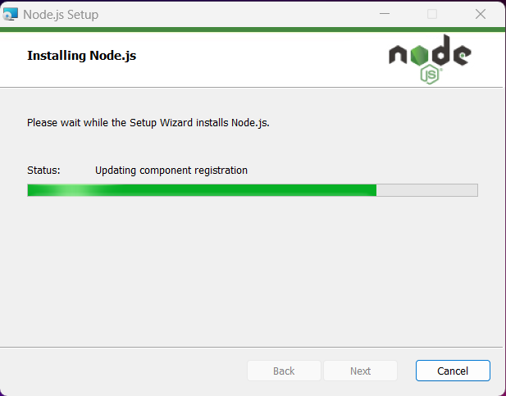

* Set up Android Studio for Android development.

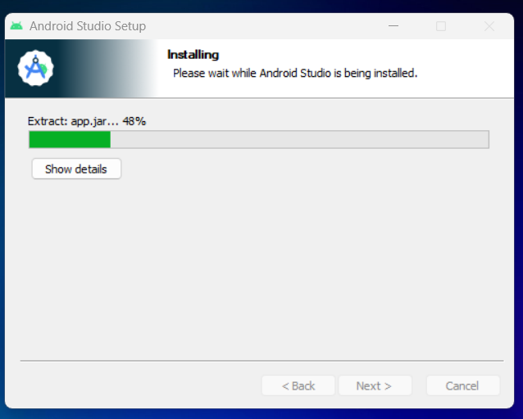

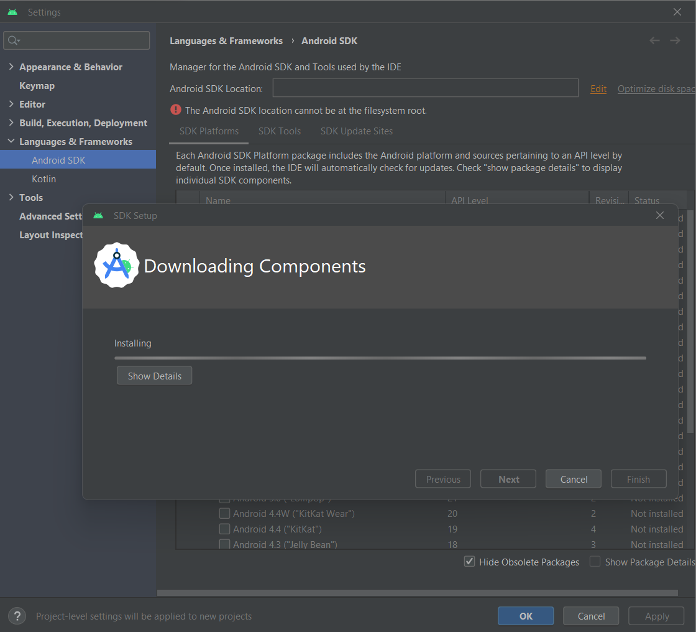

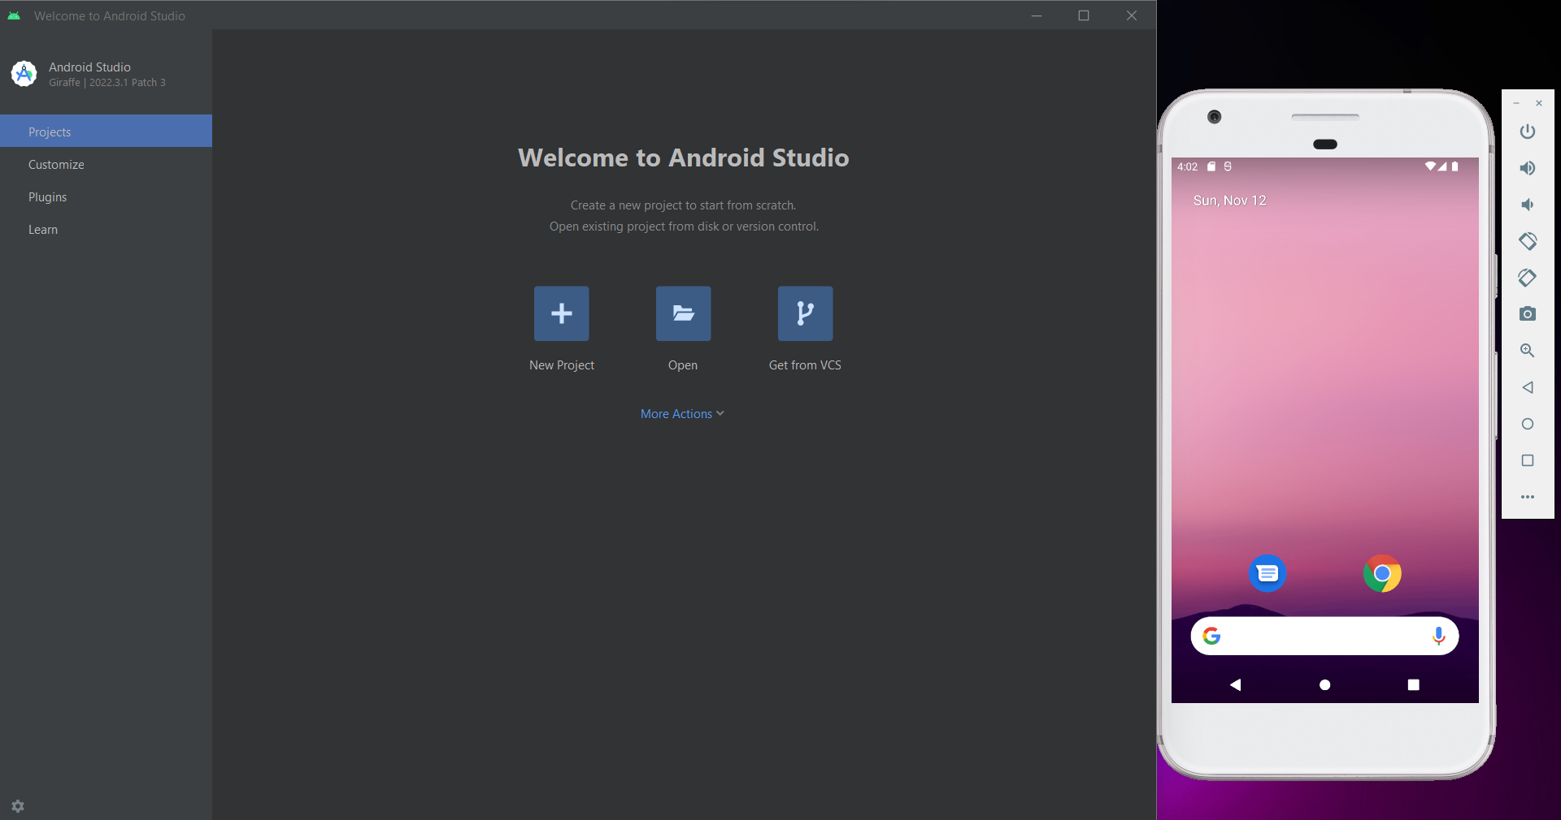

1. **Create a React Native Project:**

Open a terminal and using the following commands:

- npx react-native init newapp

- cd newapp

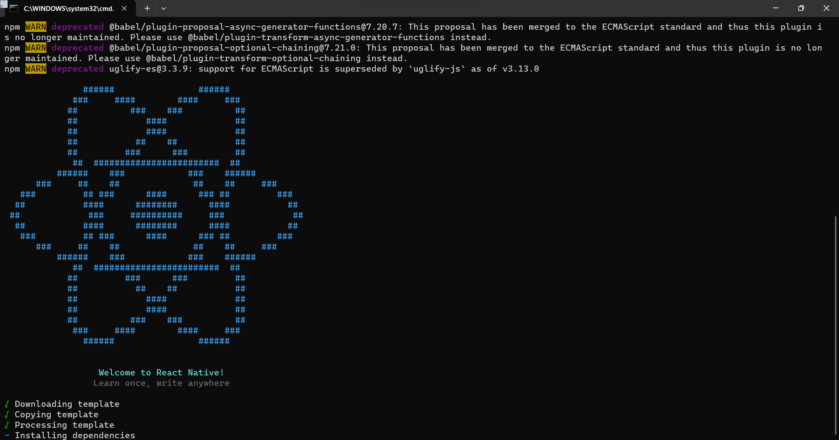

1. **Run React Native App:**

Start the React Native app using:

- npx react-native run-android

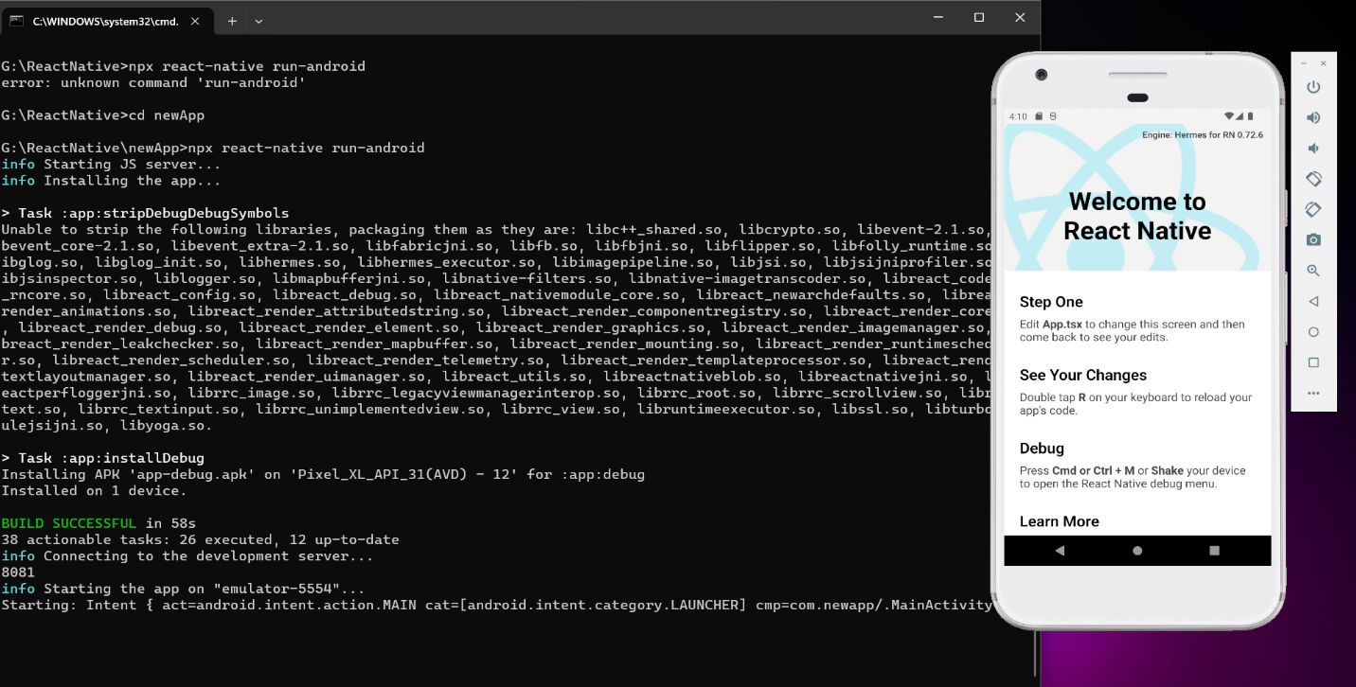

**Conclusion:**

React Native provides a powerful solution for developers to build versatile and efficient mobile applications using familiar technologies.

**References:**

1. React Native: <https://reactnative.dev/docs/environment-setup>
2. Android Studio: <https://developer.android.com/studio>
3. Node : <https://nodejs.org/en/download>
4. Package Manager: <https://chocolatey.org/contact/trial>